**DEPARTMENT OF INFORMATION AND COMMUNICATION TECHNOLOGY**

**VII SEMESTER B.TECH(IT/CCE)**

**PROGRAM ELECTIVE –IV WEB INTELLIGENCE - ICT 4024**

**ASSIGNMENT - I**

1. Machines A and B produce 10% and 90% respectively of the production of a component intended for the motor industry. From experience, it is known that the probability that machine A produces a defective component is 0.01 while the probability that machine B produces a defective component is 0.05. If a component is selected at random from a day’s production and is found to be defective, find the probability that it was made by

(i) machine A

(ii) machine B

1. Using the data from Fig. Q2, compute the minhash signature for each column if we use the following hash functions:

(a) h1(x) = 2x + 4 mod 5.

(b) h2(x) = 3x − 1 mod 5.

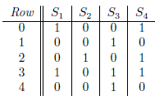

Fig. Q2

1. For the given web graph in Fig.Q3, compute the page rank using power method.

0.2

0.3

0.3

0.8 0.4 0.6

Fig.Q3

1. For the given web graph in Fig Q4, compute the page rank if the teleportation rate is 0.14

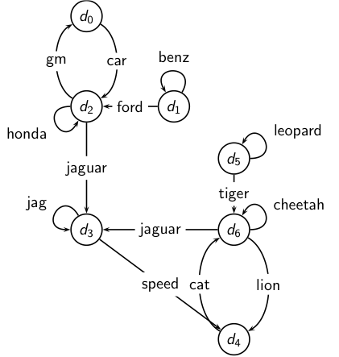

Fig. Q.4

1. Construct the inverted index for the given documents Doc1 and Doc2.

|  |  |
| --- | --- |
| **Doc 1** | **Doc 2** |
| I did enact Julius Caesar: I was  killed i’ the Capitol; Brutus killed  me. | So let it be with Caesar. The noble  Brutus hath told you Caesar was  ambitious: |